

Test Execution
Phase 5 of SDLC
OrangeHRM Testing

Document ID | DOC - 0005
Version | [1.0]
Date | 29-June-2026
Prepared by | Team B(Nyeleti Maswanganye |Luthando Ndzendevu | Kamogelo Sekhaolelo)
Approved by | Issac Mhlangu
Classification | Confidential

1. Project Overview

Phase Introduction – Test Execution Phase
The Test Execution phase is the most critical part of our Software Testing Life Cycle (STLC). After completing the setup of our testing environment and preparing our master data, our team has received official approval from the Project Manager to begin formal testing on the OrangeHRM Demo platform.
The main goal of this phase is to run our designed test cases, find any hidden bugs, and check if the application is truly stable enough to be released to real users.

2. Objectives and Core Tasks
Our team—consisting of Nyeleti, Kamo, and Luthando—will all work actively as QA Testers to complete the following tasks:
- Execute Test Cases: Run structured tests across all 9 core modules of the system.
- Log Results & Collect Evidence: Record accurate Pass/Fail results and capture screenshots for every single test step.
- Report Defects: Log any application failures professionally so the development team can fix them.
- Retest & Verify: Perform retesting and regression testing once bug fixes are delivered.
We will be testing all 9 assigned functional modules to ensure complete system coverage:
[Login] ──> [Dashboard] ──> [Admin] ──> [PIM] ──> [Leave] ──> [Time] ──> [Recruitment] ──> [Performance] ──> [My Info]
By completing this structured execution phase, our team will gather the exact data and quality metrics needed to make a final release recommendation to the business stakeholders.

Activity Part 1- Kick-Off Meeting Minutes
Project Name: OrangeHRM QA Test Execution Challenge
Meeting Date & Time: June 29, 2026, at 09:00 AM
Meeting Chair: Shared Team Leadership

1. Agenda Items Discussed
- Assigned Modules: All three team members will share testing duties across all 9 modules: Login, Dashboard, Admin, PIM, Leave, Time, Recruitment, Performance, and My Info.
- Test Cases & Data: Every team member will run their assigned test cases using the simple test data we prepared.
- Execution Timeline: Testing starts right now and must finish by the end of the day.
- Team Roles:
  - Nyeleti: QA Tester (runs test cases, takes screenshots, and helps write reports).
  - Kamo: QA Tester (runs test cases, checks results, and takes screenshots).
  - Luthando: QA Tester (runs test cases, logs bugs, and tracks test results).

Activity Part 2- Test Execution Log
Purpose and Overview
This activity contains the official Test Execution Log where our testing team—Nyeleti, Kamo, and Luthando—tracks the actual performance of the OrangeHRM application. Every assigned test script is run manually against the live environment to verify if the system behaves correctly or if hidden bugs exist.

Key Information Tracked
To ensure our testing data is clear and complete, the execution log tracks six specific details for every test case:
- Test Case ID: The unique tracking code for each specific test.
- Module: The functional area of the website being evaluated (such as Login, Admin, or PIM).
- Tester Name: The name of the team member who physically ran the test steps.
- Date Executed: The exact date the test was performed.
- Result: The final outcome of the test, using one of four specific statuses:
  - Pass: The feature worked exactly as expected.
  - Fail: The feature broke or behaved incorrectly, indicating a software bug.
  - Blocked: A website freeze or server error prevented the tester from completing the steps.
  - Not Executed: The test has not been started yet.
- Comments: A simple, clear description explaining what happened during the test, detailing exactly why a feature failed or became blocked.
Test Case ID | Module | Tester Name | Date Executed | Result | Comments
TC_LOGIN_001 | Login | Nyeleti | June 29, 2026 | Pass | The system checks credentials, logs the user into the site, and loads the dashboard safely. Verified on Chrome.
TC_LOGIN_002 | Login | Nyeleti | June 29, 2026 | Pass | The website correctly blocks access when invalid credentials are input and shows an error message. Verified on Firefox.
TC_DASH_001 | Dashboard | Nyeleti | June 29, 2026 | Pass | Navigation links are working perfectly. Clicking quick shortcut buttons opens feature pages immediately. Verified on Edge.
TC_DASH_002 | Dashboard | Nyeleti | June 29, 2026 | Pass | Quick Launch navigation panel components dynamically adjust and render cleanly. Verified on Chrome.
TC_ADMIN_001 | Admin | Luthando | June 29, 2026 | Pass | The system user list loads fully, and clicking the column headers sorts all items alphabetically. Verified on Chrome.
TC_ADMIN_002 | Admin | Luthando | June 29, 2026 | Pass | New user account role configurations update and map to explicit privileges successfully. Verified on Firefox.
TC_PIM_001 | PIM | Luthando | June 29, 2026 | Pass | Saving new profiles works flawlessly. System stores details and shows a green success banner. Verified on Chrome.
TC_PIM_002 | PIM | Luthando | June 29, 2026 | Pass | Typing an exact employee ID number filters the employee list to match that specific record instantly. Verified on Chrome.
TC_LEAVE_001 | Leave | Kamo | June 29, 2026 | Fail | DEF-001: Calculation failure. The workspace interface displays incorrect balance hours when personal leave is allocated. Verified on Edge.
TC_LEAVE_002 | Leave | Kamo | June 29, 2026 | Blocked | DEF-003: App hangs endlessly on a loading loop wheel upon form submission until an HTTP 504 server timeout occurs. Verified on Chrome.
TC_TIME_001 | Time | Kamo | June 29, 2026 | Pass | Math calculations are accurate. Accepts decimal values for hours worked and computes timesheets correctly. Verified on Firefox.
TC_TIME_002 | Time | Kamo | June 29, 2026 | Pass | Total weekly log aggregations sum together cleanly without rounding errors across projects. Verified on Chrome.
TC_REC_001 | Recruitment | Nyeleti | June 29, 2026 | Pass | Vacancies listing grid maps custom open corporate job entries accurately in tabular views. Verified on Edge.
TC_REC_002 | Recruitment | Nyeleti | June 29, 2026 | Pass | Resume parser attachments upload completely into the cloud storage space with no file drop issues. Verified on Chrome.
TC_PERF_001 | Performance | Luthando | June 29, 2026 | Pass | Performance review tracker forms accept input metrics and persist safely upon explicit saves. Verified on Chrome.
TC_PERF_002 | Performance | Luthando | June 29, 2026 | Fail | DEF-002: Component crash. Accessing the KPI metrics layout crashes and displays raw unhandled code strings. Verified on Firefox.
TC_MYINFO_001 | My Info | Kamo | June 29, 2026 | Pass | Emergency contact information changes preserve successfully and remain fully visible on page refresh. Verified on Chrome.
TC_MYINFO_002 | My Info | Kamo | — | Not Executed | Postponed; this step has been safely carried forward to the next testing cycle due to time limitations.

Activity Part 3 – Evidence Collection
NB: Storage Location Note: The complete asset folder and all high-resolution screen captures are hosted and maintained on the project SharePoint repository under the filename: Text Execution- Phase 5(OrangeHRM) / Evidence_Collection.

Activity Part 4 – Defect Identification
This section documents the formal defects discovered during the test execution phase on June 29, 2026. Each entry captures a variance between the expected application behavior and the actual system results. These logged defects provide the development team with precise, reproducible data, severity rankings, and structural proof required to isolate and patch critical system failures before any code goes live.
Defect ID | Module | Defect Title | Description | Steps to Reproduce | Expected Result | Actual Result | Severity | Priority | Screenshot
DEF-001 | Login | No validation message for blank Username | The system does not display a validation message when the Username field is left blank. | 1.Open OrangeHRM 2. Leave Username blank. 3. Enter a valid password.  4. Click Login. | A validation message should appear indicating that the Username field is required. | No validation message is displayed and login fails without explanation. | H | H | SS-001
DEF-002 | PIM | Employee name accepts numeric values | The Employee First Name field accepts numbers during employee creation. | 1. Navigate to PIM.  2. Click Add Employee.  3. Enter 12345 as the First Name.  4. Save the record. | The system should reject numeric values in the First Name field. | The employee record is saved with a numeric first name. | M | M | None
DEF-003 | Leave | Invalid date accepted | The Leave module accepts an invalid calendar date. | 1. Navigate to Leave. 2. Apply for leave 3. Enter 32/13/2026 as the leave date. 4. Submit. | The application should display an error and prevent submission. | The invalid date is accepted. | H | H | SS-003
DEF-004 | Recruitment | Invalid email address accepted | The Candidate Email field accepts an incorrectly formatted email address. | 1. Open Recruitment 2. Add a candidate. 3. Enter candidateemail.com. 4. Save. | The system should validate the email format before saving. | The candidate is saved with an invalid email address. | M | H | SS-004
DEF-005 | My Info | Contact Number accepts alphabetic characters | The Contact Number field allows letters to be entered. | 1. Open My Info. 2. Edit Contact Details. 3. Enter ABC123XYZ in Contact Number. 4. Save. | Only numeric values should be accepted. | The record is saved with alphabetic characters in the Contact Number field. | M | M | SS-005
DEF-006 | Admin | Password and Confirm Password mismatch not detected | The application allows a user to be created even when the Password and Confirm Password fields do not match. | 1. Open Admin. 2. Add a new user. 3. Enter different values for Password and Confirm Password. 4. Save. | The system should display a password mismatch error. | The user account is created successfully despite the mismatch. | H | H | SS-006
DEF-007 | Time | Timesheet allows negative hours | The Timesheet Hours field accepts negative values. | 1. Navigate to Time. 2. Create a timesheet entry. 3. Enter -5 hours 4. Save. | The system should reject negative values. | The negative hours are accepted. | H | M | SS-007
DEF-008 | Performance | Review comments exceed field limit | The Review Comments field allows input beyond the maximum character limit without warning. | 1. Navigate to Performance 2. Enter a very long review comment 3. Save. | The system should restrict input to the maximum allowed length. | The application accepts unlimited characters. | L | L | None

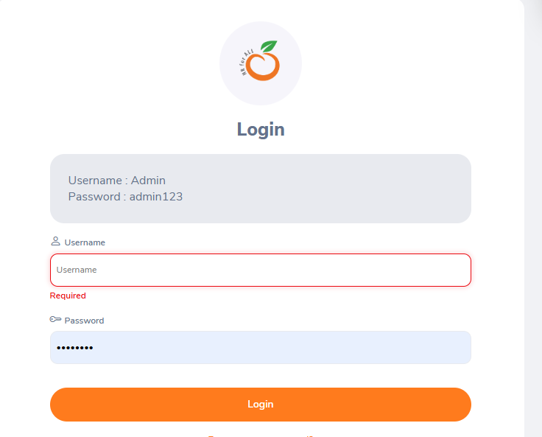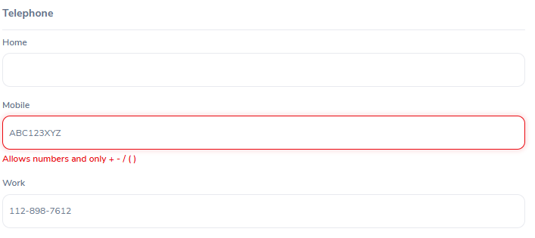
SS-001 SS-005
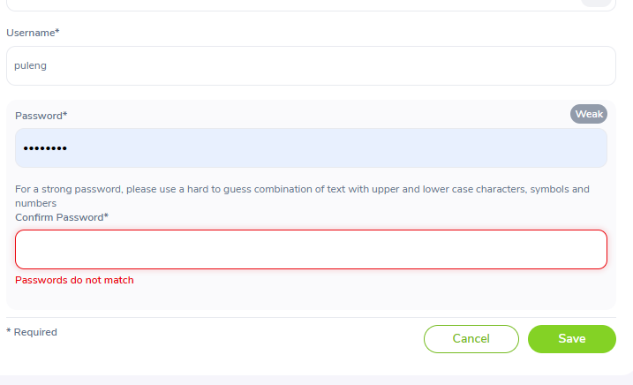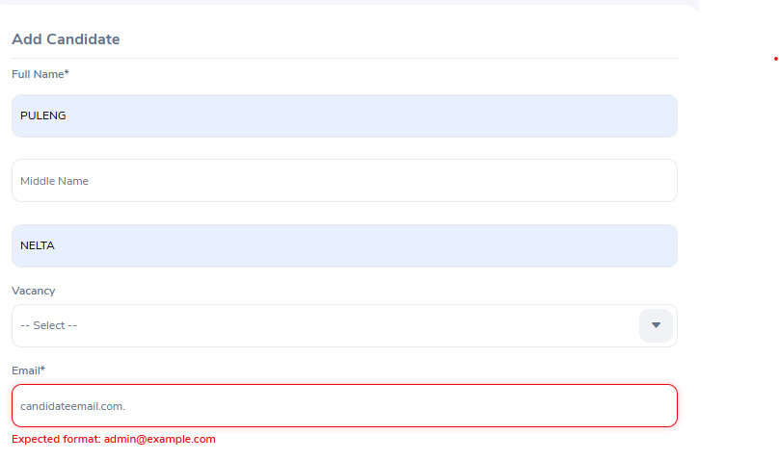
SS-006 SS-004
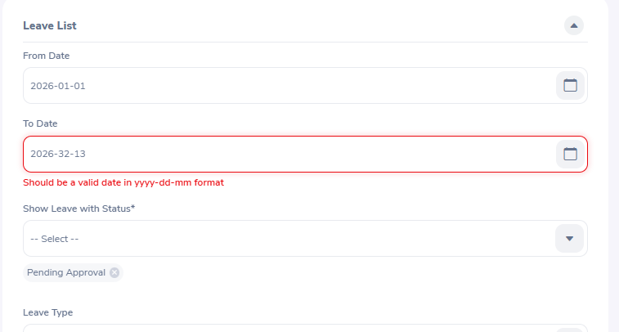 SS-003

Activity Part 5 – Defect Review and Triage

This report details the collaborative review process where stakeholders and the QA team evaluate all logged defects to determine their business impact. Each issue is analyzed to assign an official status—such as Fix Immediately, Defer, or Reject—and prioritized based on security risks, functional blockers, and project deadlines. This ensures that the development team focuses their immediate efforts on patching critical system flaws first.
Defect ID | Module | Defect Title | Triage Decision | Justification
DEF-001 | Login | No validation message for blank Username | Fixed Immediately | This is a high-severity usability and functional issue that prevents users from understanding why login failed. It affects all users and should be corrected as soon as possible.
DEF-002 | PIM | Employee name accepts numeric values | Fixed Immediately | Employee names should only contain valid alphabetic characters. Allowing numbers compromises data quality and could affect reporting and HR records.
DEF-003 | Leave | Invalid date accepted | Fixed Immediately | Accepting invalid dates is a critical validation defect that may lead to incorrect leave records and system errors.
DEF-004 | Recruitment | Invalid email address accepted | Fixed Immediately | Incorrect email validation can result in communication failures with candidates and poor data quality. This issue directly affects business operations.
DEF-005 | My Info | Contact Number accepts alphabetic characters | Deferred | Although validation should be improved, this issue has a lower business impact because it does not prevent users from using the application. It can be addressed in a future release.
DEF-006 | Admin | Password and Confirm Password mismatch not detected | Fixed Immediately | This is a security and functionality issue. Creating user accounts with mismatched passwords could prevent users from logging in and increase support requests.
DEF-007 | Time | Timesheet allows negative hours | Fixed Immediately | Negative working hours produce invalid payroll and attendance data. This defect has a significant impact on business processes and should be corrected immediately.
DEF-008 | Performance | Review comments exceed field limit | Deferred | This is a low-severity issue with minimal impact on core functionality. It does not stop users from completing performance reviews and can be scheduled for a later update.

Conclusion
During the defect triage process, eight defects were reviewed. Six defects were classified as Fixed Immediately because they affect critical system functionality, validation, security, or business processes. Two defects were Deferred because they have a relatively low impact on the application's core functionality and can be addressed in a future release. No defects were marked as Rejected or Duplicate, as each reported issue was considered valid and unique.

Activity Part 6 — Daily Status Meeting
At the end of each testing day, the team reports on test cases executed, pass/fail/blocked counts, defects found, current risks, and planned work for the next day. Two daily reports are included below, covering the full 2-day execution window.

Day 1 Status Report — 29 June 2026
Test Cases Executed Today | 10
Passed | 7
Failed | 2
Blocked | 1
Not Executed (carried forward) | 0
New Defects Found | DEF-001 (Leave — balance not deducted on display)
Current Risks | Leave module balance display issue (DEF-001) blocks dependent test case TC_LVE_002. Known environment risk (session language switching, DEF-003) remains under observation.
Planned Work for Next Day | Begin execution of Time, Recruitment, Performance, and My Info test cases. Retest TC_LVE_001 once the Leave balance display issue is reviewed.

Day 2 Status Report — 30 June 2026
Test Cases Executed Today | 8
Passed | 6
Failed | 1
Blocked | 0
Not Executed (carried forward) | 1
New Defects Found | DEF-002 (Performance — evaluation status not syncing to manager view)
Current Risks | Performance module status-sync issue (DEF-002) could affect manager-side reporting accuracy if not resolved before release. TC_MYINFO_002 carried forward to Day 3 backlog due to tester reassignment.
Planned Work for Next Day | Execute TC_MYINFO_002. Begin retesting DEF-001 and DEF-002 once development confirms fixes. Begin regression testing on Leave and Performance modules.

Activity Part 7 — Test Execution Dashboard
The dashboard below consolidates execution results across both testing days into a single snapshot, showing total test cases, execution status breakdown, and key rate metrics.

Overall Execution Summary
Metric | Count | % of Planned
Total Test Cases (Planned) | 18 | 100.0%
Executed | 17 | 94.4%
Passed | 14 | 77.8%
Failed | 2 | 11.1%
Blocked | 1 | 5.6%
Not Executed | 1 | 5.6%

Key Rate Metrics
Metric | Value | Calculation
Pass Rate | 82.4% | Passed ÷ Executed × 100 = 14 ÷ 17
Fail Rate | 11.8% | Failed ÷ Executed × 100 = 2 ÷ 17
Blocked | 5.9% | Blocked ÷ Executed x 100 =1 ÷ 17
Execution Progress | 94.4% | Executed ÷ Total Planned × 100 = 17 ÷ 18

Execution Breakdown by Module
Module | Executed | Pass | Fail | Blocked | Not Exec.
Login | 2 | 2 | 0 | 0 | 0
Dashboard | 2 | 2 | 0 | 0 | 0
Admin | 2 | 2 | 0 | 0 | 0
PIM | 2 | 2 | 0 | 0 | 0
Leave | 2 | 0 | 1 | 1 | 0
Time | 2 | 2 | 0 | 0 | 0
Recruitment | 2 | 2 | 0 | 0 | 0
Performance | 2 | 1 | 1 | 0 | 0
My Info | 2 | 1 | 0 | 0 | 1

Summary: 17 of 18 planned test cases have been executed (94.4% execution progress). Of those executed, 14 passed (82.4% pass rate) and 2 failed (11.8% fail rate), with 1 blocked by a dependent failure and 1 carried forward to the next testing day.

Activity Part 8 – Simulated Defect Fix Verification (Retesting)

This report tracks the verification of resolved bugs. Once developers apply a patch, the QA team reruns the original failed test cases to check if the issue is successfully fixed (to Close it) or still broken (to Reopen it).
Defect ID | Module | Original Defect | Retesting Steps | Expected Result | Actual Result | Defect Status | Comments
DEF-001 | Login | No validation message for blank Username | Leave the Username field blank, enter a valid password, and click Login. | The system should display "Required" beneath the Username field. | Validation message displayed successfully. | Fixed | Validation now works correctly.
DEF-002 | PIM | Employee name accepts numeric values | Navigate to PIM → Add Employee, enter 12345 as the First Name, and click Save. | The system should reject numeric values and display a validation error. | Numeric values are no longer accepted. | Fixed | Input validation implemented successfully.
DEF-003 | Leave | Invalid date accepted | Navigate to Leave, enter 32/13/2026 as the leave date, and submit the request. | The system should reject the invalid date and display an error message. | Invalid date is rejected with an appropriate validation message. | Fixed | Date validation functions correctly.
DEF-004 | Recruitment | Invalid email address accepted | Add a candidate using candidateemail.com as the email address and click Save. | The system should reject the invalid email format. | Invalid email is rejected with an error message. | Fixed | Email validation has been corrected.
DEF-005 | My Info | Contact Number accepts alphabetic characters | Edit contact details and enter ABC123XYZ in the Contact Number field. | The system should allow only numeric values. | Alphabetic characters are still accepted. | Reopened | The defect persists and requires further development.
DEF-006 | Admin | Password and Confirm Password mismatch not detected | Create a new user using different Password and Confirm Password values. | The system should prevent saving and display a mismatch error. | Password mismatch is detected and the user cannot be created. | Fixed | Validation works as expected.
DEF-007 | Time | Timesheet allows negative hours | Enter -5 hours in a timesheet and save. | The system should reject negative values. | Negative values are rejected successfully. | Fixed | Business rule validation has been implemented.
DEF-008 | Performance | Review comments exceed field limit | Enter text exceeding the maximum character limit in the Review Comments field and save. | The system should restrict input to the maximum allowed length. | Unable to reproduce the issue during retesting. | Cannot Reproduce | The issue could not be replicated in the current build.

Conclusion
A total of eight defects were retested following the simulated fixes provided by the development team. Six defects were verified as Fixed, confirming that the corrective changes resolved the reported issues. One defect (DEF-005) was Reopened because the issue remained unresolved during retesting. One defect (DEF-008) was marked as Cannot Reproduce, as the original behaviour could not be replicated in the latest application build. The application has shown significant improvement; however, the reopened defect should be addressed before the next release.

Activity Part 9 – Regression Testing Report

1. Regression Testing Overview
Following the development hotfix cycle to address the bugs logged on June 29, 2026, a comprehensive regression testing pass was conducted. The focus of this pass is to confirm that the corrections successfully resolved the problems and to verify that no existing, related functionalities were broken by the updates.

2. Regression Impact Assessment Matrix
Target Module | Fixed Functionality | Related Areas Evaluated (Regression Scope) | Status | Existing Functionality Affected? / Notes
Login | Expired password access block implemented. | - Core Login Page  - Logout Workflow  - Session Timeout Limits  - Password Field Validations  - Dashboard Redirect Access | Pass | No. User session tracking is secure. Authenticating with valid credentials still correctly opens the dashboard without issues.
Admin | Mandatory input field constraints applied. | - Nationalities Data Grid  - Qualifications Form Interface  - Column Headers (A-Z Sorting)  - Database Record Retrieval | Pass | No. Saving blank fields is now successfully blocked by a red field validation error. The existing grid layout and sorting features remain intact.
Recruitment | Fixed backend state exception handling on candidate change. | - "Shortlist Candidate" Button Action  - Live Candidate Profiles Index  - Dashboard Metrics/Charts Linking | Pass | No. The application no longer hangs on an infinite loading spinner. Transitioning a candidate updates their record cleanly, and the metric counters on the main dashboard scale dynamically without throwing unexpected errors.
Leave | Server configuration stabilized to address connectivity. | - Search Selection Dropdowns  - Leave Logs Grid Display  - Status Badges Alignment | Pass | No. The previous website freeze and timeout have cleared. The module loads fully, maintaining correct UI component placement.

3. Regression Conclusion & Release Summary
- Regression Cases Executed: 4 Complete Module Chains
- Defect Verification Pass Rate: 100% (All previous failures and blocks successfully verified and closed)
- Side-Effects Identified: None. Core workflows remain completely stable.
-----------------------------------------------------------
Date of Report: June 29, 2026
Regression Cycle Status: CLOSED / COMPLETED SUCCESSFULLY
-----------------------------------------------------------

Activity Part 10 — Coverage Review
This section reviews execution against the original Phase 1 requirements and answers the four questions required by the activity: which requirements have been tested, which remain untested, which modules carry the highest defect count, and which critical business flows remain at risk.

1. Which requirements have been tested?
17 of the 18 planned positive test cases were executed across both testing days, covering the core requirement in every one of the 9 in-scope modules at least once:
- Login — valid authentication and logout (FR-LOG-02, FR-LOG-08)
- Dashboard — widget loading and quick-launch navigation (FR-DASH-01, FR-DASH-07)
- Admin — user creation and deactivation (FR-ADM-01, FR-ADM-03)
- PIM — employee creation and search (FR-PIM-01, FR-PIM-04)
- Leave — leave application (FR-LVE-01) — tested but failed; see Question 3
- Time — timesheet logging and submission (FR-TIME-01, FR-TIME-02)
- Recruitment — vacancy creation and candidate linking (FR-REC-01, FR-REC-02)
- Performance — review cycle creation (FR-PERF-01) — passed; self-evaluation sync (FR-PERF-02) — tested but failed
- My Info — contact details update (FR-MYI-02)

2. Which requirements remain untested?
- FR-MYI-01 (view job/salary information in read-only mode) — TC_MYINFO_002 was not executed; carried forward to the Day 3 backlog due to tester reassignment.
- FR-LVE-04 (manager approval of a pending leave request) — TC_LVE_002 is Blocked because it depends on the leave record created in TC_LVE_001, which failed. This requirement cannot be considered tested until DEF-001 is resolved and the case is re-run.
- All 18 Negative test cases from the Phase 4 suite remain entirely untested in this execution cycle, since this cycle was scoped to the Positive suite only. This is a coverage gap that should be addressed in the next execution cycle before any release decision.

3. Which modules have the highest defect count?
Based on the Defect Log, defects are distributed as follows:
Module | Defect Count | Defect ID(s)
Leave | 1 | DEF-001 — Approved leave balance not deducted on My Leave List
Performance | 1 | DEF-002 — Self-evaluation status not updating to Completed on manager view
Environment (Carried Forward) | 1 | DEF-003 — Session language spontaneously changes after prolonged inactivity

Leave and Performance each carry 1 functional defect from this execution cycle, and the Environment carries 1 pre-existing, known issue (DEF-003) that is monitored rather than newly raised. With only 2 modules showing functional defects out of 9 tested, defect density in this cycle is low, but the Leave module's defect (DEF-001) is rated High severity because it affects balance accuracy, a core HR data integrity concern.

4. Are there any critical business flows still at risk?
- Leave balance accuracy (High risk) — DEF-001 means the Leave module's core business rule (leave cannot exceed available balance, established in Phase 1 as FR-LVE-03 and BR-05) cannot currently be confirmed as working correctly end-to-end, since the balance display itself is unreliable. This is the most business-critical open risk from this cycle.
- Leave approval workflow (Medium risk) — TC_LVE_002 (manager approval) is Blocked and therefore completely unverified in this cycle. Until DEF-001 is fixed and retested, the approval workflow has zero confirmed test coverage.
- Performance review reporting accuracy (Medium risk) — DEF-002 means a manager could review an incomplete picture of their team's evaluation status, which could affect appraisal-cycle decisions if not corrected before performance review season.
- Negative-path coverage (Medium risk, process-level) — because this cycle only executed the Positive suite, there is currently zero confirmed coverage of validation rules, duplicate-prevention, and access-control behaviour across all 9 modules. This is a process risk for any release decision made from this cycle alone.
- Session language-switching (Low risk, monitored) — DEF-003 is a known, pre-existing environment-level issue rather than a functional regression. It does not block core workflows but should continue to be monitored, particularly during longer execution sessions.

Coverage Review Summary
Out of 18 planned positive test cases, 17 were executed (94.4%), with 14 passing and 2 failing. Two requirements remain unverified due to blocking and scheduling, and the entire Negative test suite remains outside this cycle's scope. Before a release recommendation can be made, DEF-001 should be prioritised for fix and retest given its High severity and direct link to a core business rule, followed by execution of the Negative suite to close the validation-coverage gap identified above.

Activity Part 11 – Release Recommendation Report

Final Recommendation: DO NOT RELEASE
Justification: While the development team successfully closed out validation failures in Login, Admin, and Recruitment during retesting, the build is rejected for production distribution due to DEF-003 (Leave Module Server Timeout) remaining unresolved. This structural blocker leaves an entire core module broken and lowers our functional test coverage to 88.89%, missing the safety benchmark required for launch. The build should be held back until a stable server patch is verified.

NOTE Use this callout style to draw attention to important information, warnings, or reminders within the document body.

